System Models for

myKSU Student Mobile Application

Prepared by:

**Brandon Merck – *Coach, Developer***

[bmerck@students.kennesaw.edu](mailto:bmerck@students.kennesaw.edu)

**Alix Teschner – *Developer, Tester***

ateschne@students.kennesaw.edu

**Ethan Dillon *– Developer, Tester***

edillon7@students.kennesaw.edu

**Joshua Gregory – *Developer, Tester***

[jgrego42@students.kennesaw.edu](mailto:jgrego42@students.kennesaw.edu)

Delivery: 24 Feb. 2025

|  |  |  |  |  |  |  |  |
| --- | --- | --- | --- | --- | --- | --- | --- |
| **Table of Contents** | | | |  | | | *i* |
| 1. Project Background | | | | | ……………………………………………………………. | | 01 |
| 1. Data Flow Diagram | | | | | ………………………………………………………......... | | 02 |
| 1. Use Cases & User Stories | | | | | | ……………………………………………………... | 03 |
| 1. Decision Trees | | | ……………………………………………………………......... | | | | 13 |
| 1. Dialog Maps | | …………………………………………………………………… | | | | | 17 |
| 1. Credits | ……………………………………………………………………......... | | | | | | 19 |

1. **Project Background**

Kennesaw State University has been using the Owl Express website for years to allow students to register for classes, view their schedules, and pay their tuition all in one place. But despite more and more colleges creating mobile apps to allow students to view and interact with this information on the go, KSU does not have a mobile app equivalent to Owl Express. And as the next generation continues to be more dependent on their mobile devices, it is becoming more necessary to have an app equivalent for every internet service. And while Owl Express is a functional and helpful tool, its design is not well suited for mobile viewing, which is especially important for things as important as registering for classes or making tuition payments. But not only does the lack of an Owl Express app make KSU fall behind technologically, but it makes it harder for students in an increasingly mobile world. College students lead very busy lives, and because of this it is easier to miss important deadlines like registration times and tuition due dates, especially with young people who do not use or check their email as much as previous generations.

1. **Data Flow Diagram**

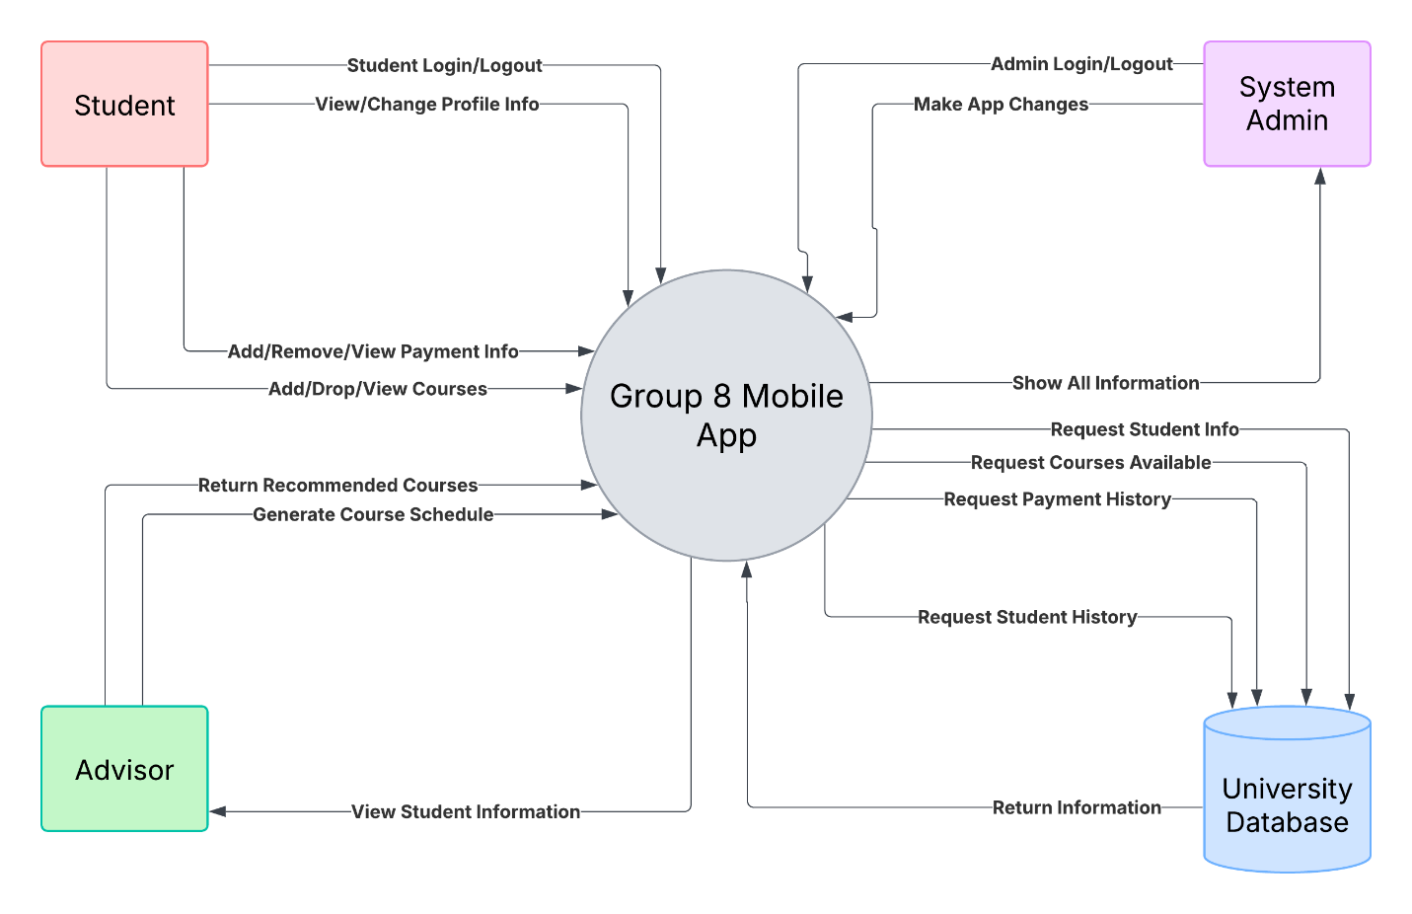

[ Brandon Merck ]

1. **Use Cases & User Stories**

## **1. Register for Classes**

* **Use Case ID Number:** UC-001
* **Use Case NAME:** Register for Classes
* **Created By:** Ethan Dillon
* **Date Created:** 2/22/2025
* **Primary Actor:** Student
* **Secondary Actor:** None
* **Triggering Event:** The student wants to enroll in courses for an upcoming semester.
* **Brief Description:** This use-case describes the process of a student searching for and registering for classes through the KSU mobile app.
* **Preconditions:**
  1. The student is logged into the mobile app.
  2. The registration period for the desired semester is open.
* **Post-conditions:**
  1. The student is successfully registered for the selected classes.
  2. The student's schedule is updated.
* **Includes:**
  1. Select Semester
  2. Search for Courses
  3. Register for Courses
* **Normal Flow:**

1. The system displays a dropdown menu displaying available semesters.
2. The student selects a semester.
3. The system displays a search page with fields for CRN, Subject, Course Number, and Instructor.
4. The student enters the Course Registration Number (CRN) into the CRN field.
5. The system displays the class information with a button to register.
6. The student presses the register button.
7. The system confirms the registration with a notification, including the course name, CRN, and semester.
8. The system returns to step 3, allowing the student to search for and register for additional classes, or to exit the registration process.

* **Alternative Flow:**

1. **4a. Invalid CRN:**
   * + The system displays a notification saying that no CRN matched to the student.
     + The use case continues on step 3.
2. **4b. Class not found:**
   * + The system displays a notification saying that no class was found matching parameters.
     + The use case continues on step 3.
3. **6a. The selected class is full:**
   * + The system displays a notification saying that the selected class is full.
     + The use case continues on step 3.
4. **6b. Error registering:**
   * + The system displays a notification saying that there was an error registering for the class.
     + The use case continues on step 3.

* **Exceptions:**
  1. **System Error:**
     + If a system error occurs at any point, the system displays a generic error message and allows the student to try again or contact support.
* **Special Requirements (Performance):**
  1. The search functionality (step 3) should be optimized to provide results quickly, even with a large number of courses.
  2. The registration process (steps 5-7) should be completed within a reasonable time frame.

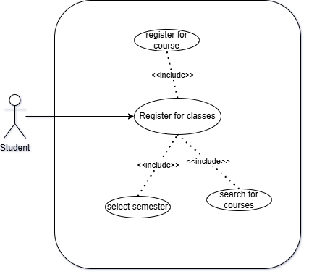

## **2. View Schedule**

* **Use Case ID Number:** UC-002
* **Use Case NAME:** View Schedule
* **Created By:** Ethan Dillon
* **Date Created:** 2/22/2025
* **Primary Actor:** Student
* **Secondary Actor:** None (or potentially "Calendar App" if you want to explicitly show the interaction)
* **Triggering Event:** The student wants to view their class schedule.
* **Brief Description:** This use case describes how a student can view and export their class schedule through the KSU mobile app.
* **Preconditions:** The student is logged into the mobile app.
* **Post-conditions:**
  1. The student has viewed their schedule.
  2. (Optional) The student has exported their schedule to a chosen format.
* **Includes:**
  1. View Schedule on Screen
  2. Export Schedule
* **Normal Flow:**

1. The system displays the student's schedule for the current semester in a weekly view, with options to switch to a daily or list view. The schedule shows class names, times, locations, and instructors.
2. The student can navigate between different weeks and semesters.
3. The student has the option to:
   1. **View Schedule:** The student can simply view the schedule on the screen.
   2. **Export Schedule:** The student can select an "Export" option.
4. If the student chooses to export, the system displays a list of export options, including:
   1. **Mobile Calendar:** Export the schedule to the device's default calendar app.
   2. **PDF:** Export to PDF file.
   3. **Image:** Export the schedule as an image.
5. The student selects the desired export option.
6. The system initiates the export process according to the selected option.
   1. **Mobile Calendar Export:** The system prompts the student to grant permission to access the calendar app. If granted, the system adds the classes to the calendar.
7. The system displays a confirmation message indicating the success or failure of the export.

* **Alternative Flow:**

1. **1a. No Schedule Found:** 
   * + The system displays a message informing the student that they have no classes scheduled for the selected semester.
2. **6a. Export Error:** 
   * The system displays an error message indicating the reason for the export failure.

* **Exceptions:**
  1. **System Error:**
     + If a system error occurs at any point, the system displays a generic error message and allows the student to try again or contact support.
* **Special Requirements (Performance):**
  1. The initial display of the schedule (step 1) should be quick and responsive.
  2. The export process (steps 6-7) should complete within a reasonable time frame.

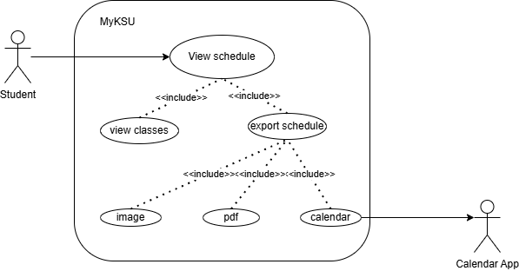

## **3. Pay Tuition**

* **Use Case ID Number:** UC-003
* **Use Case NAME:** Pay Tuition
* **Created By:** Ethan Dillon
* **Date Created:** 2/22/2025
* **Primary Actor:** Student
* **Secondary Actor:** Payment Gateway
* **Triggering Event:** The student wants to make a tuition payment.
* **Brief Description:** This use case describes how a student can make a tuition payment through the KSU mobile app.
* **Preconditions:**
  1. The student is logged into the mobile app.
  2. The student has a tuition balance due.
* **Post-conditions:**
  1. The tuition payment is successfully processed.
  2. The student's account is updated to reflect the payment.
* **Includes:**
  1. Select Payment Amount
  2. Choose Payment Method
  3. Process Payment
* **Normal Flow:**
  1. The system displays the student's tuition statement, including:
     + Semester
     + Tuition type
     + Amount due
     + Due date
     + Summary of previous payments with dates

1. The student enters the amount they want to pay.
2. The system validates the payment amount.
3. The system displays different payment options (Apple Pay, PayPal, Google Pay, Credit Card).
4. The student selects a payment option.
   1. **Credit Card:** If the student selects "Credit Card," the system prompts them to enter their credit card information.
   2. **Other Payment Options:** If the student selects another payment option, the system redirects them to the appropriate payment gateway.
5. The system displays a confirmation window asking if the student wants to confirm the payment of X amount.
6. The student confirms the payment.
7. The system processes the payment.
8. The system displays a confirmation message with a summary of the payment statement, including a transaction ID and the option to export the statement.
   1. **Export Options:** The system provides options to export the statement as a PDF or send it via email.

* **Alternative Flow:**
  1. **3a. Invalid Payment Amount:**
     + The system displays an error message indicating the reason for the invalid amount.
     + The system returns to step 2.
  2. **9a. Payment Declined:**
     + The system displays an error message indicating that the payment was declined.
     + The system may provide suggestions for resolving the issue (e.g., contact the bank).
     + The system returns to step 2.
  3. **9b. Payment Error:**
     + The system displays an error message indicating that there was a problem processing the payment.
     + The system may advise the student to try again later or contact support.
     + The system returns to step 2.
* **Exceptions:**
  1. **System Error:**
     + If a system error occurs at any point, the system displays a generic error message and allows the student to try again or contact support.
  2. **Payment Gateway Error:**
     + If an error occurs with the payment gateway, the system displays an appropriate error message and may advise the student to try a different payment method or contact support.
* **Special Requirements (Performance):**
  1. Payment processing (step 9) should be completed within a reasonable time frame, taking into account potential delays with the payment gateway.
  2. The system should be able to handle a high volume of concurrent payment transactions.

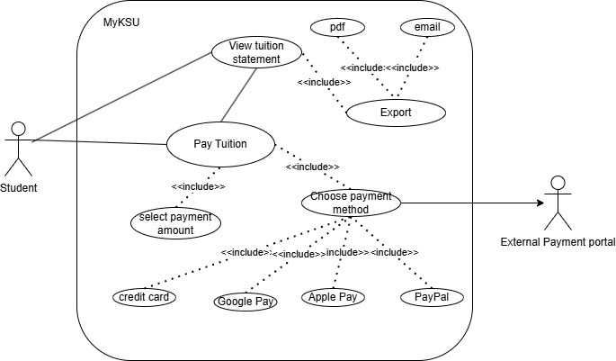

## **4. Communicate with Digital Advisor**

* **Use Case ID Number:** UC-004
* **Use Case NAME:** Communicate with Digital Advisor
* **Created By:** Ethan Dillon
* **Date Created:** 2/22/2025
* **Primary Actor:** Student
* **Secondary Actor:** Digital Advisor System
* **Triggering Event:** The student seeks information or assistance about KSU.
* **Brief Description:** This use-case describes the process of a student interacting with the digital advisor to answer questions related to academics, financial aid, student services, and campus life at KSU.
* **Preconditions:**
  1. The student is logged into the mobile app.
  2. The digital advisor system is available.
* **Post-conditions:**
  1. The student got the information that they were seeking.
  2. OR the digital advisor was unable to provide the requested information.
* **Includes:**
  1. Enter a question.
  2. View frequently asked questions.
* **Normal Flow:**

1. The system displays a chatbot interface with the received message "Hi [Student name], I am your digital advisor here to help in any way I can!". The interface includes options to view previous conversations, type a question, view frequently asked questions, and access help resources and contact information.
2. The student types in a question about academic deadlines.
   1. **Answer Found:** The digital advisor provides a clear and concise answer to the student's question (e.g., "The last day to drop a class is [date]").
   2. **Answer Not Found:** The digital advisor informs the student that it cannot answer the question and suggests alternative resources (e.g., "I'm still learning about that. You can find more information on the [Registrar's Office website/Financial Aid portal/Student Services page]").
3. The student clicks on the frequently asked questions (FAQs) button.
   1. **FAQ:** The system displays a list of FAQ categories. E.g., Academics, Financial Aid, Campus Life.
   2. **FAQ:** The student selects a category.
   3. **FAQ:** The system displays a list of FAQs within that category.
   4. **FAQ:** The student selects an FAQ to view the answer.

* **Alternative Flow:**
  1. **2a. Question Unclear:**
     + The digital advisor responds with, "I'm not sure I understand your question. Could you please rephrase it?" or "Can you provide more details about what you're looking for?"
  2. **3c. Multiple Answers:**
     + The digital advisor presents the student with a list of options or categories to choose from.
* **Exceptions:**
  1. **System Error:**
     + If a system error occurs, the system displays a message like, "Oops, something went wrong. Please try again later or contact support."
  2. **Network Error:**
     + If there is a network connectivity issue, the system displays a message like, "You appear to be offline. Please check your network connection and try again."
  3. **Service Unavailable:**
     + If the digital advisor service is temporarily unavailable, the system displays a message like, "The digital advisor is currently unavailable. Please try again later."
* **Special Requirements (Performance):**
  + The digital advisor's response time should be 5 seconds or less for most queries. More complex queries may take longer, but the system should provide feedback to the student.
  + The digital advisor should provide accurate answers at least 90% of the time.
  + The digital advisor should personalize responses based on the student's profile when possible.

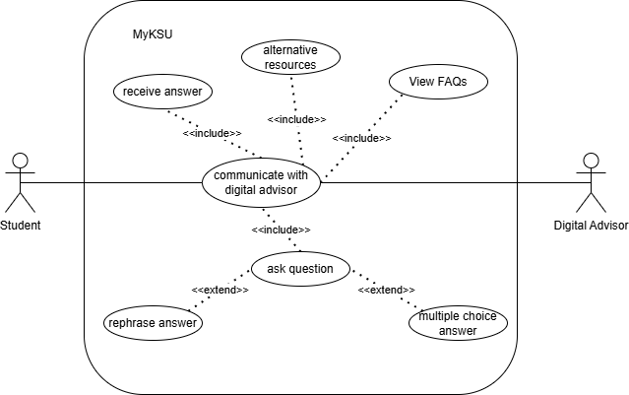

[Ethan Dillon]

# **5. User Stories**

**Use Case 1: Register for Classes:**

* + As a student, I want to be able to search for and register for classes through the KSU mobile app, so that I can easily enroll in the courses I need for the upcoming semester.

**Use Case 2: View Schedule:**

* + As a student, I want to be able to view and export my class schedule through the KSU mobile app, so that I can easily see my class details and manage my time.

**Use Case 3: Pay Tuition:**

* As a student, I want to be able to view my tuition statement and make payments through the KSU mobile app, so that I can easily manage my financial obligations to the university.

**Use Case 4: Communicate with Digital Advisor:**

* As a student, I want to be able to ask questions and access FAQs through a digital advisor in the KSU mobile app, so that I can quickly find information and get assistance with university-related topics.

**Use Case 5: Assist Student with App:**

* As a registration administrator, I need to be able to assist students with using the app to register courses and access student registration data.

**Use Case 6: Post-Release System Maintenance:**

* As an IT manager for KSU, I need to be able to test the application, view system and user metrics, and make changes to the system to ensure the system is highly-available for KSU students.

**Use Case 7: Analyzing Business Strategy:**

* As a business manager for KSU, I need to be able to view certain system and user metrics that allow me to view whether the product is providing a good return on investment and ensuring that the system meets student data compliance standards.

[ Ethan Dillon ]

1. **Decision Trees**

Enrolling in a class:

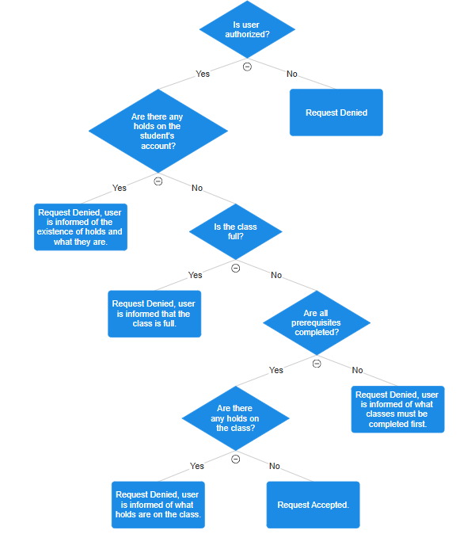

Unenrolling from a class:

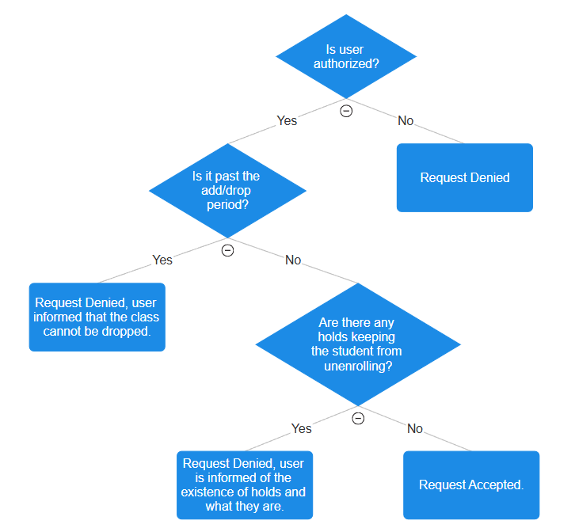

Making a payment:

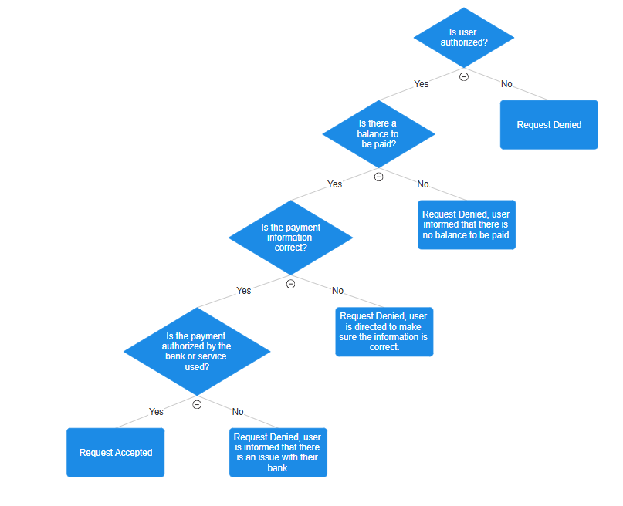

Editing profile:

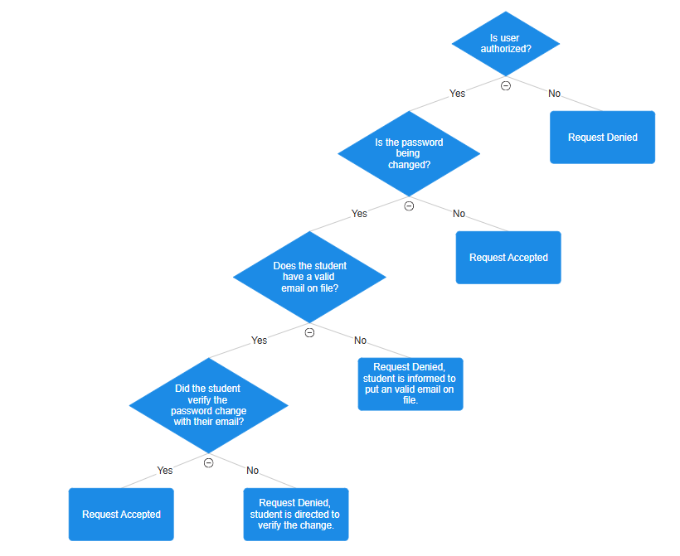

[ Alix Teschner ]

1. **Dialogue Maps**
   1. Student User Group:

* 1. Administrator User Group:

* 1. IT Personnel User Group:

* 1. Business Manager User Group:

[ Joshua Gregory ]

1. **Credits**
2. Data Flow Diagram
   1. Brandon Merck
3. Use Cases & User Stories
   1. Ethan Dillon
4. Decision Trees
   1. Alix Teschner
5. Dialogue Maps
   1. Joshua Gregory